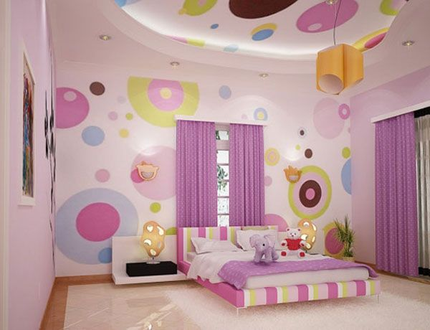
Names: ______________________________________
______________________________________
______________________________________
Hour: _______________

Company: _____________________________________

Room you are creating: ___________________________

