Debate Questions
- What is so special about the name of your triangle?

- What is always true about the angles?
- What is always true about the sides?

- Where are these triangles used/visible in everyday life?

- Do these contain other triangles within them, (ie. Equilateral, scalene, isosceles)?

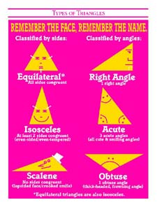
- How many different ways can you draw your triangle?

- Any other interesting thoughts you can think of regarding your triangle?

