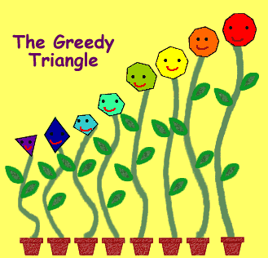
The Greedy Triangle

Name: _______________________________________________
Sides: _______________________________________________
Angles: ______________________________________________
Contains the following triangles (circle all that apply):
Acute Obtuse Equilateral Scalene Isosceles Right
Objects made of this shape: _____________________________
____________________________________________________

Name: _______________________________________________
Sides: _______________________________________________
Angles: ______________________________________________
Contains the following triangles (circle all that apply):
Acute Obtuse Equilateral Scalene Isosceles Right
Objects made of this shape: _____________________________
____________________________________________________

Name: _______________________________________________
Sides: _______________________________________________
Angles: ______________________________________________
Contains the following triangles (circle all that apply):
Acute Obtuse Equilateral Scalene Isosceles Right
Objects made of this shape: _____________________________
____________________________________________________
Name: _______________________________________________
Sides: _______________________________________________
Angles: ______________________________________________
Contains the following triangles (circle all that apply):
Acute Obtuse Equilateral Scalene Isosceles Right
Objects made of this shape: _____________________________
____________________________________________________

Name: _______________________________________________
Sides: _______________________________________________
Angles: ______________________________________________
Contains the following triangles (circle all that apply):
Acute Obtuse Equilateral Scalene Isosceles Right
Objects made of this shape: _____________________________
____________________________________________________

Name: _______________________________________________
Sides: _______________________________________________
Angles: ______________________________________________
Contains the following triangles (circle all that apply):
Acute Obtuse Equilateral Scalene Isosceles Right
Objects made of this shape: _____________________________
____________________________________________________

Name: _______________________________________________
Sides: _______________________________________________
Angles: ______________________________________________
Contains the following triangles (circle all that apply):
Acute Obtuse Equilateral Scalene Isosceles Right
Objects made of this shape: _____________________________
____________________________________________________

Name: _______________________________________________
Sides: _______________________________________________
Angles: ______________________________________________
Contains the following triangles (circle all that apply):
Acute Obtuse Equilateral Scalene Isosceles Right
Objects made of this shape: _____________________________
____________________________________________________

Name: _______________________________________________
Sides: _______________________________________________
Angles: ______________________________________________
Contains the following triangles (circle all that apply):
Acute Obtuse Equilateral Scalene Isosceles Right
Objects made of this shape: _____________________________
____________________________________________________

