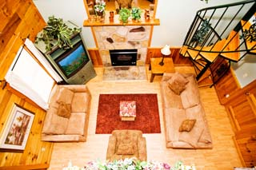
Congratulations! You have been invited to create a blueprint of your dream location. You will be competing against other top decorators in the area, so be ready to bring your A-game! This room can be any shape you choose. There are a few restrictions in your room.
There must be:
- Trapezoid
- Parallelogram
- Rhombus
- Rectangle
- Square
- Kite
This room can be a bedroom, living room, recreation room, outdoor arena, vacation getaway, amusement park, etc. All that is asked is for you to design the floor plan. For each shaped object in the room, you must provide appropriate scaled dimensions. For example, you would not want a rectangular, 2x3 foot bed since you could not fit into it. Provide the side lengths, angle measures, area, perimeter, and a drawing of each shape in it’s furniture state on the table provided for each of the needed six quadrilaterals.
Turn in your proposal in a packet in the following order:
- Cover Page – name, hour, company, room you are creating
- Quadrilateral Pieces of Paradise – object, side lengths, angle measures, scale factor, ratio of sides, areas, ratio of areas, perimeters, ratio of perimeters, enlargement/reduction
  - Trapezoid
  - Parallelogram
  - Rhombus
  - Rectangle
  - Square
  - Kite
- Blueprint – Colorful layout with all 6 quadrilaterals included with reasonable scale dimensions
- Who Am I? WS – Completed with an answer and reason why for all 7 descriptions
- Shape Finders WS – Completed table with all 7 quadrilaterals
- Hierarchy WS – Completed notes sheet with all properties included and extra notes given in videos
- Reflection – What did you enjoy most about this project? What would you change? What was the coolest thing you learned? How will you continue to use this information? Where else are quadrilaterals used in real life? (Make sure it is typed double spaced with no grammar or spelling errors, about 1 page)

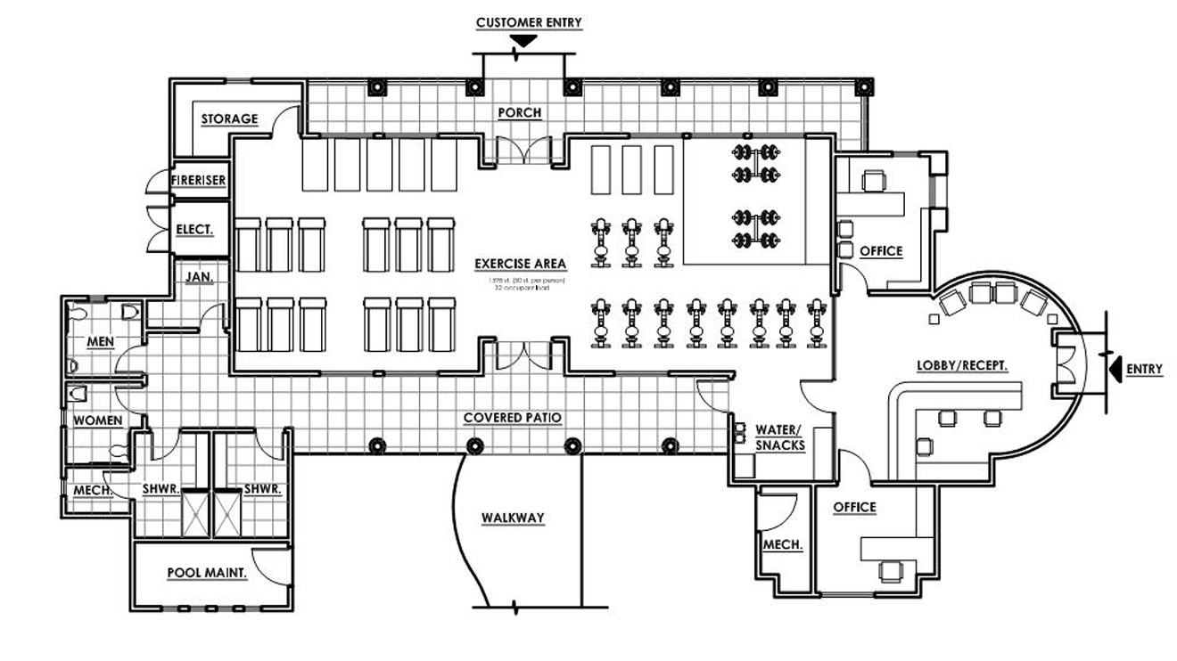
Examples of Blueprints:
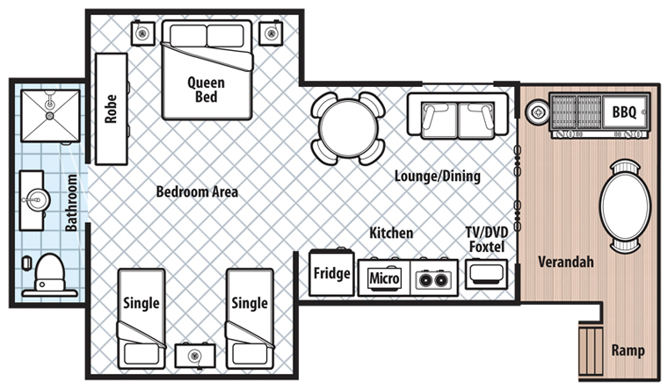
Hotel Room
Work Out Facility

