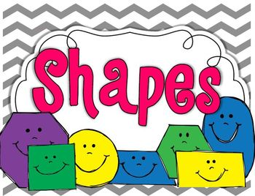
Name: ______________________________________ Hour: _____
Searchin’ for
Take time to explore all these wonderful shapes in everyday life! Shapes are all around us, just as we read in The Greedy Triangle in class today. Identify the name of the shape on the left and two things found in the world with the same shape.

Shape: ______________________________
Real Life Items: ___________________________________________________________

Shape: ______________________________
Real Life Items: ___________________________________________________________

Shape: ______________________________
Real Life Items: ___________________________________________________________

Shape: ______________________________
Real Life Items: ___________________________________________________________

Shape: ______________________________
Real Life Items: ___________________________________________________________

Shape: ______________________________
Real Life Items: ___________________________________________________________

Shape: ______________________________
Real Life Items: ___________________________________________________________

Shape: ______________________________
Real Life Items: ___________________________________________________________

Shape: ______________________________
Real Life Items: ___________________________________________________________

Shape: ______________________________
Real Life Items: ___________________________________________________________

Did you find any other fun shapes? List them below with a picture of the shape.

